Worksheet for Palmer Park Field Trip
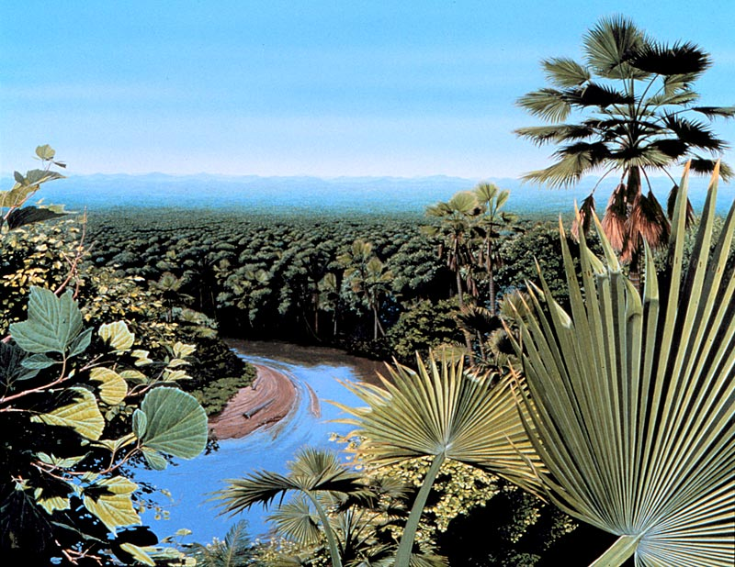
Dawson Paleoenvironment
NAME: _______________________________

I.Structural Geology
Palmer Park is located on the southern portion of what geologic structure? Note: this geologic structure surrounds Denver, Colorado and the surrounding area.
II.Sedimentology & Paleoenvironment
- Please answer the following about the sedimentology of Palmer Park:
- What evidence is used to determine the location of the source of sediments that compose the Dawson Arkose? Please provide 4 lines of evidence.

- What sedimentary structures did you see in the Dawson Arkose? Please list at least 3.

- What paleoenvironment is indicated by the rock type, sedimentary structures, and fossils?

- What is a crevasse splay? How does it form?
III.Paleontology
- Please answer the following regarding the geologic age and fossils of the Dawson Arkose:
- What Geologic Era & Period (name) is the Dawson Arkose?

- Describe the type of fossils you saw. How complete are the remains?

- Please define the following types of fossil preservation:

    - Mold and Cast

    - Permineralization

    - Carbonization

